Reading Cloud - Quick Start Guide

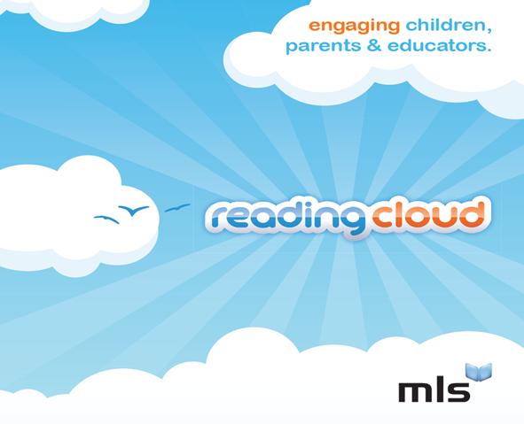

About Reading Cloud:
The Reading Cloud is a fantastic new online reading community designed to engage students, parents and educators in reading for pleasure. The Reading Cloud uses the very latest technologies to really capture the imagination of students, linking real and virtual reading experiences to drive up literacy standards and develop core reading skills.
Contents
About Reading Cloud: 2
Home Screen: 4
Star Review: 4
Featured Author: 4
Trending: 4
Meet the Author: 4
Most Popular Books: 4
Quick Search: 4
Word of the day: 4
Fact of the day: 4
News: 4
Twitter Feed: 4
Facebook Feed: 4
Who Next: 4
Logged-On Screen: 6
My Blog: 6
My Home Library: 6
My Profile: 6
My Account: 6
What’s on your mind? 6
Timeline: 6
My Info: 6
My Blog 7
My Home Library 8
My Profile 9
My Account 10
My Info 11
Quick Search 12
Advanced Search 13

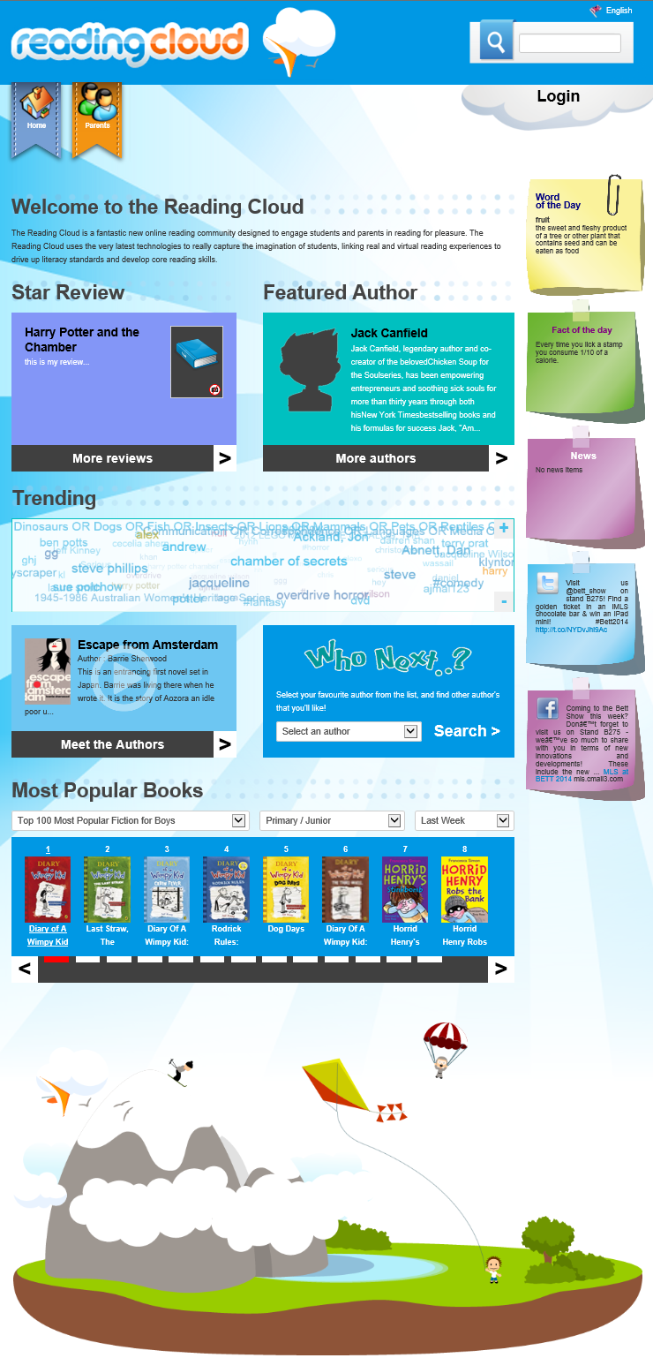
Meet the Author
Most Popular Books
Featured Author
Star Review
Twitter Feed
Who Next
Facebook Feed
News
Fact of the day
Word of the day
Quick Search
Trending

Home Screen:
When first loading Reading Cloud the home screen will be shown. Below is a brief description of each area.

Star Review:
The star review is a chosen review which then appears on the front page. Clicking on More Reviews will open up the other reviews written by students.

Featured Author:
An author can be chosen as a ‘Featured Author’, for example for highlighting the release of a new series of books. Clicking on More Authors opens up a list of all authors in the system.

Trending:
Similar to ‘The Cloud’ in .NET, this shows the most popular searches and authors.

Meet the Author:
A random ‘Meet the Author’ video is selected each time the page loads. Clicking on Meet the Author links to a page will all meet the author videos available.

Most Popular Books:
Quickly run reports to see the most popular books for girls / boys / age ranges / etc.

Quick Search:
Quickly search for items by title / author / etc.

Word of the day:
Randomly selects a word of the day from a predefined customisable list.

Fact of the day:
Randomly selects a fact of the day from a predefined customisable list.

News:
Shows the news items from the library / area.

Twitter Feed:
Shows the latest Tweet from a definable feed.

Facebook Feed:
Shows the latest Facebook post from a definable feed.

Who Next:
Work out who to read next based on other authors that a borrower enjoys.
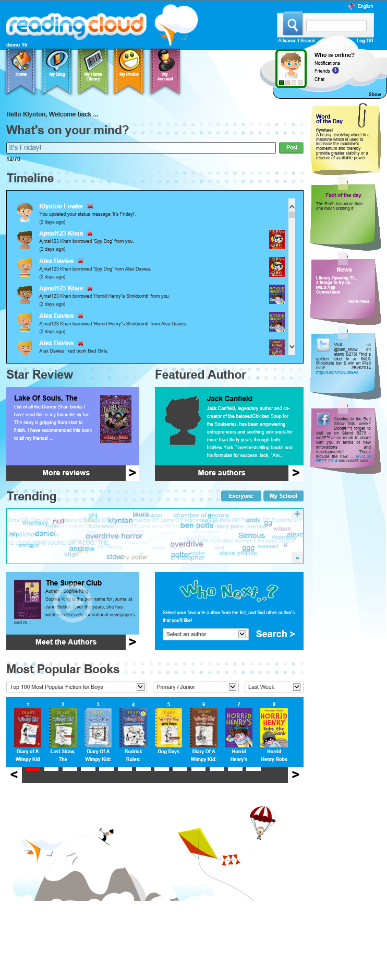
My Blog
Timeline
What’s on your mind?
My info
My Account
My Profile
My Home Library

Logged-On Screen:
After logging onto the Reading Cloud some additional options / features will be available. Below is a brief description of each area.

My Blog:
Links to the My Blog page, where borrowers can keep a blog of their activities.

My Home Library:
Links to the My Home Library page where borrowers can catalogue books / CDs / DVDs / etc that they have at home and manage loans of these items to other Reading Cloud users.

My Profile:
Links to My Profile where borrowers can enter basic information about themselves and create / edit their avatar.

My Account:
Links to My Account where their Current Loans / Past Loans / Reservations / in the library system can be seen.

What’s on your mind?
Allows users to set a status message that all their friends can see.

Timeline:
Shows all activity of the user and their friends (e.g. What books have been liked, Home Loans, etc).

My Info:
Shows information on friends, including:
- Who is Online – The online status of friends
- Notifications – Notifications of friend requests / Home Library loan requests
- Friends – How many friends a user has and the status of each
- Chat – Instant Chat with friends / See history of Chat messages.

My Blog
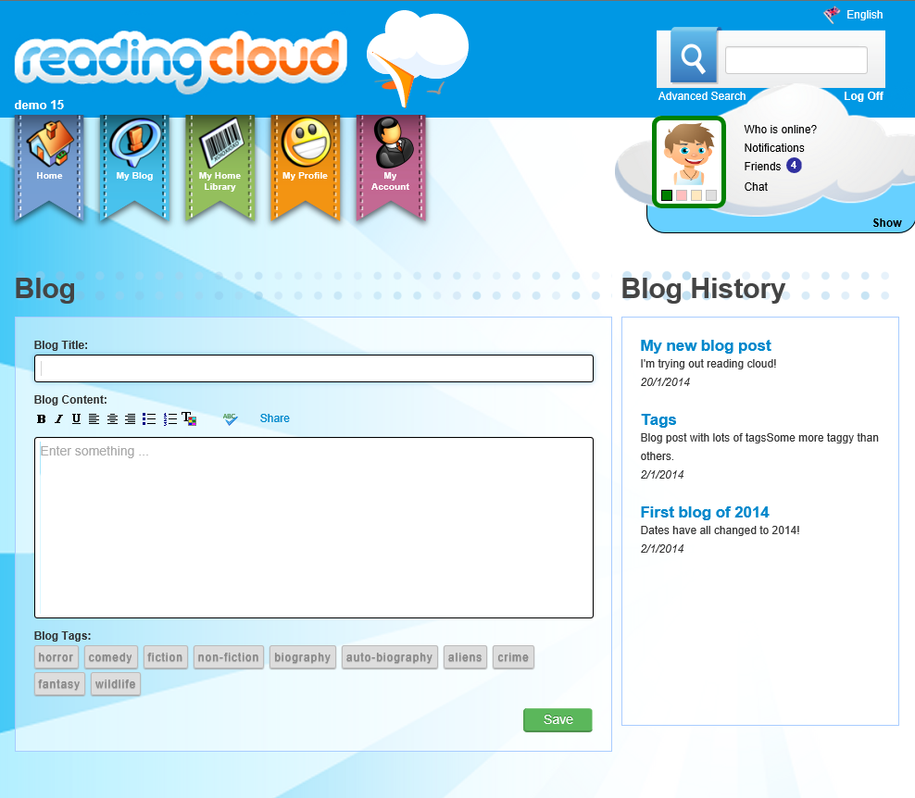
The My Blog screen allows users to write blog posts for their friends to see and comment on.

My Home Library
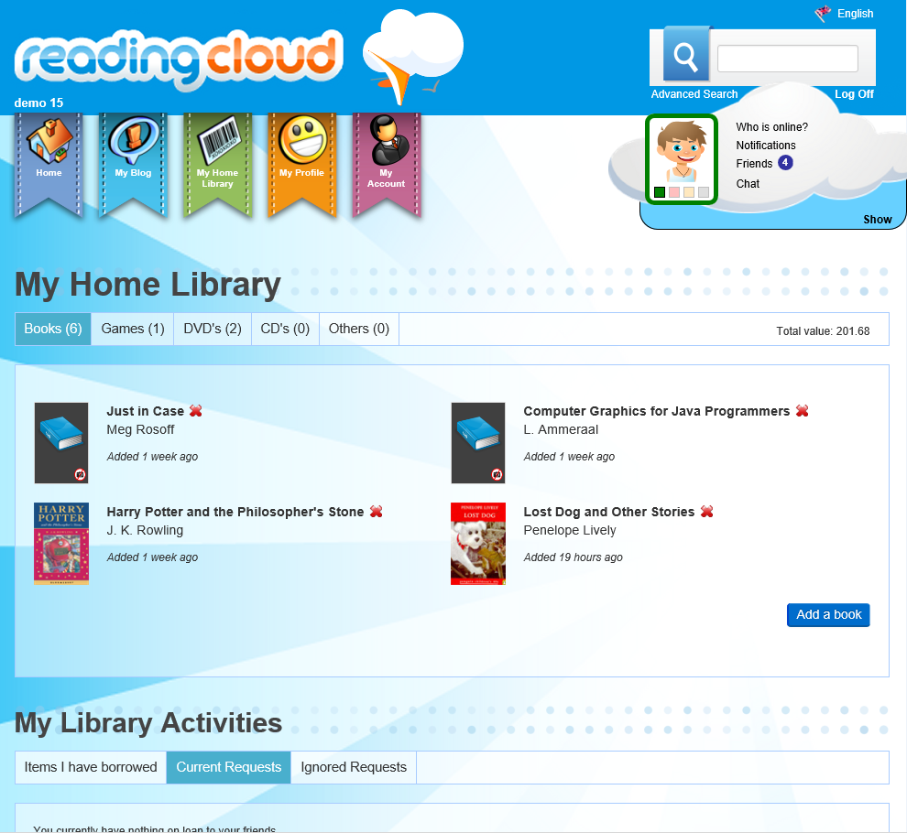
My Home Library is an area where users can catalogue their own items to create a home library of books, DVDs, CDs, Games, etc. Once an item has been catalogued friends of the user can see them on their profile and request to borrow them. The system then allows for the tracking of these loans sending notifications between the two users when the book is requested, confirmation of receipt, requested back, received back, etc.

My Profile
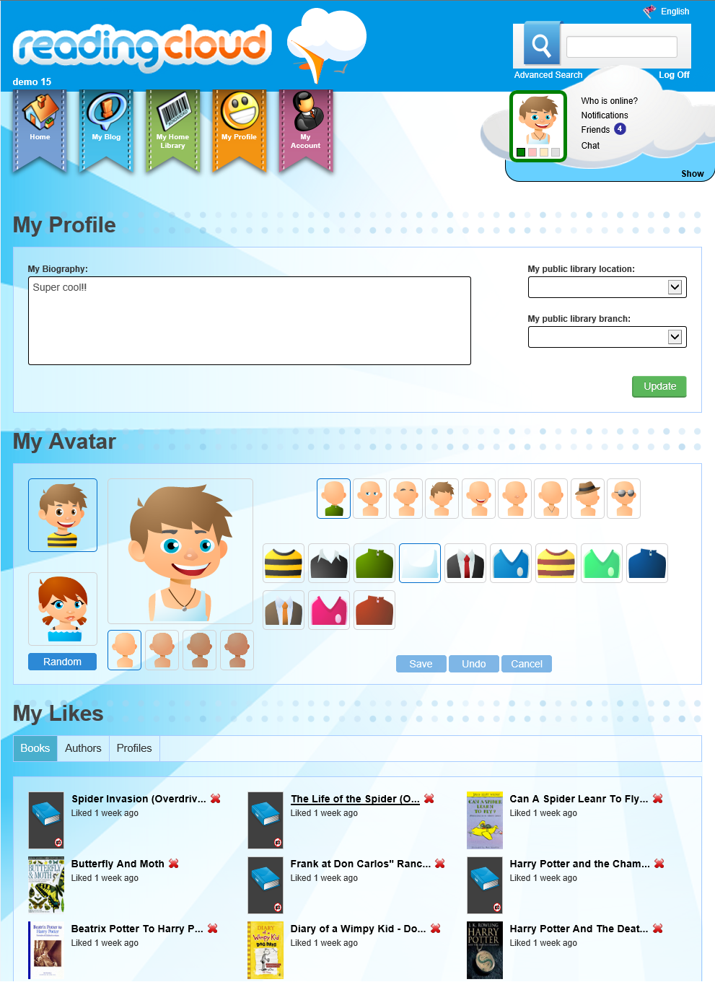
The My Profile area allows for a brief Biography to be entered, an Avatar to be created and it displays all the items that a user has Liked.

My Account
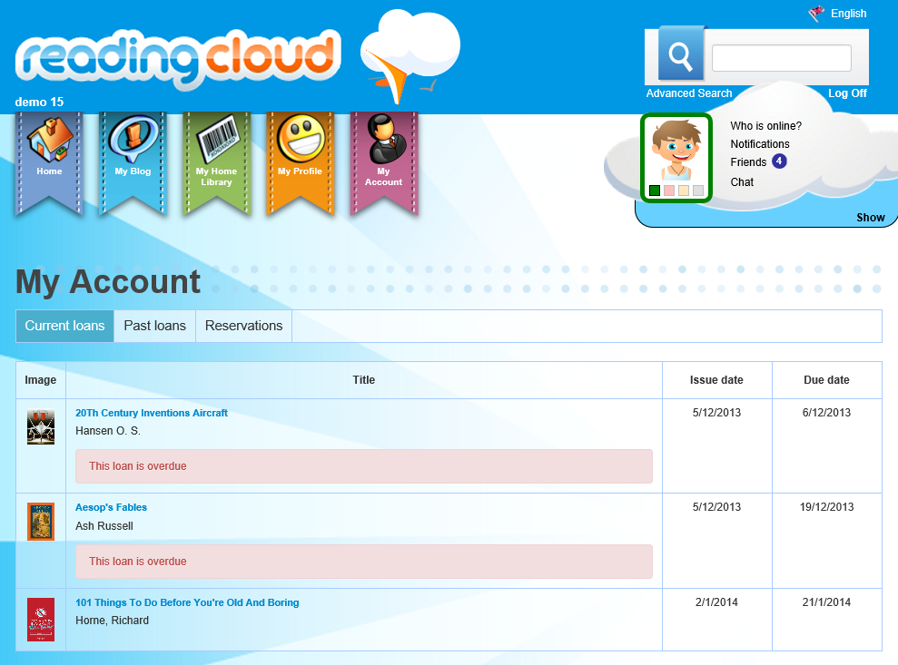

My Account shows a user’s Current Loans, Past Loans and Reservations. It will display if items are overdue and (if the option is enabled in the Management area of the library system) it will allow items that are not yet overdue to be renewed.

My Info
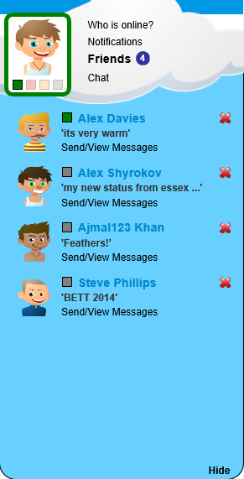

The My Info area allows users to see all their friends, which are currently online, what notifications they have (friend requests / home library loan requests) and chat with their friends through Reading Cloud.

Quick Search
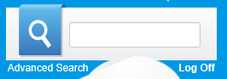

The Quick Search box is available in the top right of every page and allows for quickly searching by author, title, student name, etc.

After entering a search it will by default list all resources that match.

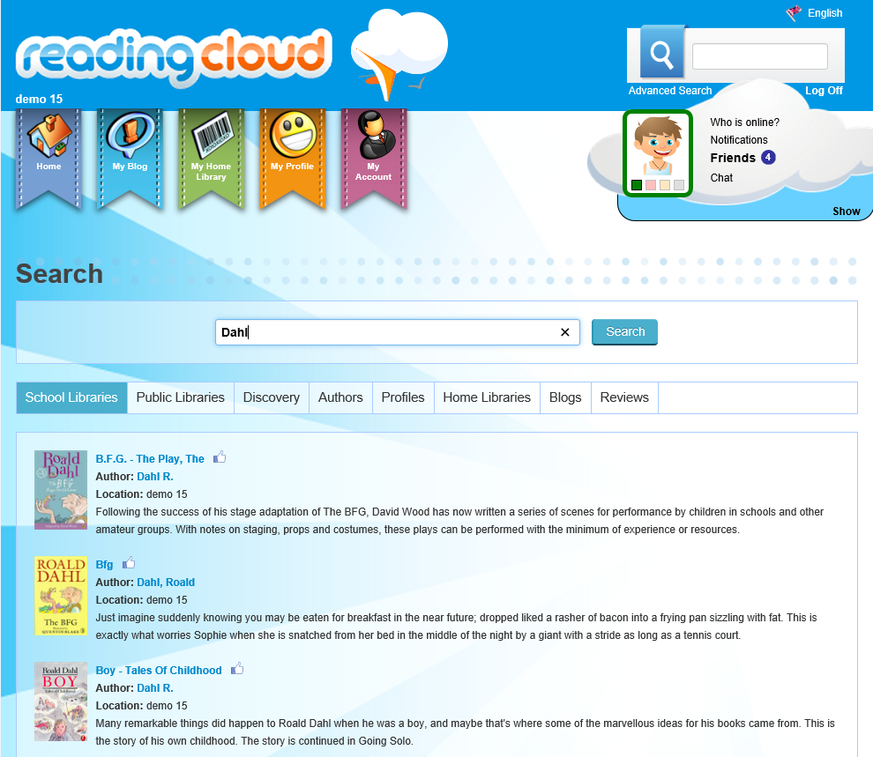

The user can then choose to instead list Profiles of students in the system, Blog posts, Reviews, etc.

Advanced Search
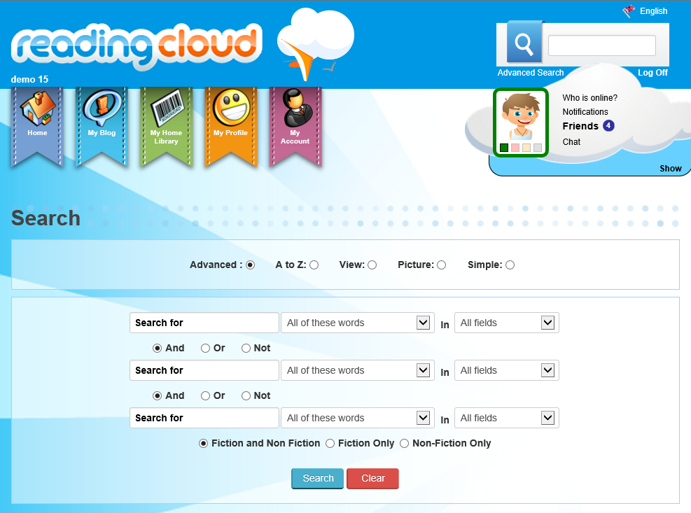

Advanced Search allows for more advanced searches and will be familiar to any previous .NET library users. As per previous system the A-Z, View, Picture and Simple search functions are available by clicking the tabs.

